Oyster Task Force Meeting
May 11, 2021, 1:00pm
New Orleans Lakefront Airport
6001 Stars and Stripes Blvd.
New Orleans, LA
I. Pledge of Allegiance
II. Roll Call:
Voting Members Present:
Mitch Jurisich
Willie Daisy
Brad Robin
Brandt Lafrance
Peter Vujnovich
Shane Bagala
John Tesvich
Dan Coulon
Jakov Jurisic

Voting Members Absent:
Tracy Collins
Byron Encalade
Al Sunseri
Sam Slavich

Non-Voting Members Present:
Brian Marie
Harry Vorhoff
Carolina Bourque

Non-Voting Members Absent:
Justin Gremillion
Karl Morgan
Brian Lezina

John Tesvich expressed concern with membership and absences, the task force made a request to reach out to all appointing organizations of any members who have missed 3 or more meetings in row without an excused absence

III. Peter Vujnovich motioned to approve the April 6, 2021 meeting minutes, 2nd by Willie Daisy. Motion carries.

Peter Vujnovich motioned to amend the agenda by adding item A. under new business, “To Hear an Update on the Moratorium Lifting Phase Zero Applications, 2nd by Brad Robin. Motion carries.

Brad Robin motioned to approve the agenda as amended, 2nd by Peter Vujnovich. Motion carries.

IV. Treasury Report
Remaining Fund Balance- $495,744
Remaining Budget Balance- $111,359

Peter Vujnovich motioned to approve the treasury report as presented, 2nd by Willie Daisy. Motion carries.

V. Committee Reports:
- Public Private: No report
- Enforcement Report:
APRIL 6-MAY 4, 2021
Region 4
Iberia-no report

Region 5
Cameron-no report
Calcasieu-no report
Vermillion-no report

Region 6
Terrebonne

Lafourche

Region 8
St Bernard
1-No gear license in possession
1-Violate Sanitary Code (Refrigeration)
2-Violate Sanitary Code (Log Book)
113 Sacks Seized
Plaquemines
1-Unlawfully take oysters from state water bottoms
1-Violate sanitation code (log book)
1-Violate sanitation code (No Tarp)
1-Fail to display proper numbers on vessel
2 Sacks Seized

- Legislative Committee: St Tammany, St Bernard and Plaquemines Parishes have written letters of opposition in response to the Mid-Barataria Sediment Diversion
Made comments at the parish council meetings on the negative impacts of the Mid Barataria Sediment Diversion, it was mentioned that Black Bay was in decline and that is not true, believe this is being said so that Black Bay is written off as a non-productive area for oysters. Also it was brought up by CPRA how many jobs the sediment diversion will create but it was never mentioned how many jobs it will destroy
Dan Coulon stated that when you hear CPRA say new jobs created that does not mean jobs created for Plaquemines, Jefferson, or the local parishes but when you say jobs lost it is referring to jobs lost in the local area. You hear about jobs created and you find people from all over the world filling these positions and it does not necessarily mean jobs for the local community

Jakov Jurisic stated that CPRA made a comment that the oyster industry is not harvesting oysters today the same way we did 30 years ago, generations of my family have harvested oysters in the areas we are harvesting today up until recently due to the current issues

Taylor Naquin commented to never stop trying to submit public comment on these projects

Harry Vorhoff stated that there is $300 million dollars there as mitigation and would like the industry’s input on how this should be spent

John Tesvich stated that the $300 million has not been appropriated so it’s not real money, this happened in Caernarvon the state ended up not having the money, if the money has not been appropriated it is not real money. We have been promised damages before, this happened in 1927 the levee was blown out in Caernarvon and wiped out the areas in Plaquemines and St. Bernard, the people were promised restitution it was done by the New Orleans and Baton Rouge business interests who said do not worry you will get paid but when it came time for the state to pay out they said they didn’t have the money. The money that CPRA is talking about is not even a fraction of the amount of what it will cost the state to actually mitigate the damages. The actual cost of damages are going to be $1 billion plus. Already had a project called Davis Pond that came in and the oyster fishermen were going to be affected the Department of Natural Resources working with the task force went to Congress and appropriated $14 million to move nine thousand acres of oyster leases removed. Who will appropriate the money for mitigation and that’s just for the oystermen you also have all the other industries and the levees, etc.

George Ricks stated that this is what he has have been saying for 8 years, the EIS lays it out there that the diversion will cause permanent major adverse impacts. You cannot use BP money to mitigate a project so where will the money come from? $305 million is not going to even come close
- Legal Committee- no report
- Research/ Coastal Restoration Committee: the joint committee met today to receive a report from Sea Grant on AOC Grant Programs
The committee received the report and some requests, 1. Does the task force want to participate in an advisory group for this grant program, 2. What members of the board would be interested in participating in a selection committee for the program? 3. Does the task force want to create a subcommittee and how would the task force like the information to be brought forward? and 4. This is a living document so there will be opportunity to make adjustments and/or solicit changes
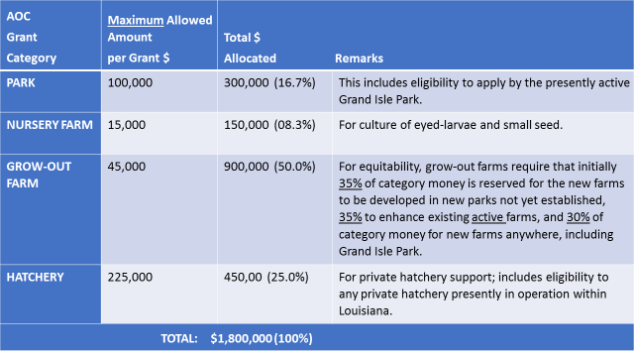
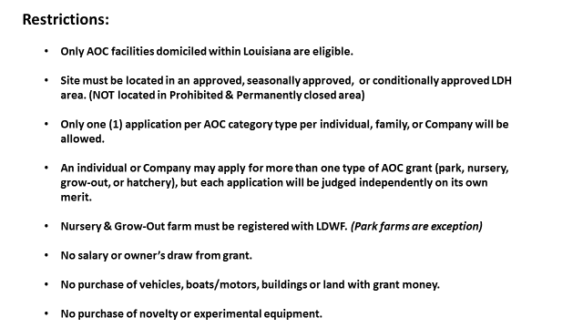
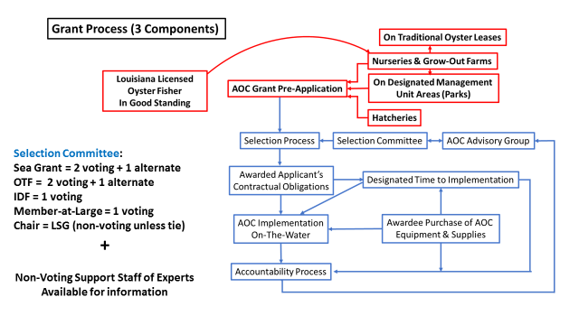
Requested that the OTF create an AOC advisory group to provide feedback for the program; this might be a few members appointed from the task force or a committee designated for this purpose
Websites: http://laseafoodfuture.com/aoc
http://www.lafisheriesforward.org
Zoom Public meeting= May 19, 2021, at 6pm
Dan Coulon stated that when he first heard about AOC he thought that it was better for other states, because it requires more equipment, this might be a good opportunity to develop something for Louisiana to form a program, would like for the task force to have a vote on participation in the program in the requested ways
John Tesvich will those wishing to participate in the advisory group be excluded from applying for the grant; no it does not prevent you from sitting on the committee or applying
John Tesvich motioned to support further development and implementation of the AOC grant and program that has been presented and that the OTF provide representatives as requested, 2nd by Peter Vujnovich. Motion carries with one opposition Jakov Jurisic, and 1 abstained Mitch Jurisich
John Tesvich nominated Peter Vujnovich, Peter Vujnovich stated that he wouldn’t mind filling in as an alternate. Peter Vujnovich suggested Brandi Shelley and Steve Pollock as possible nominations
Pete Vujnovich was nominated for the alternate position, suggested Byron Encalade, Al Sunseri, the chairman will work on this and get Earl Melancon the names as soon as possible
Mitch Jurisich stated that being that the funding source of the program is controversial it might be beneficial to not take action on this at the moment
Brad Robin stated he is for the program but doesn’t want it to come back and bite him and the industry, wonders if the task force should take any action on this
Jakov Jurisic made a substitute motion, to the motion on the floor, to not take any action on the AOC grant program for the time being, motion does not carry as there was not a second
John Tesvich stated that grant money is hard to come by, the fact that any money is being spent on AOC is a good thing. If we didn’t have all these other issues, AOC is a good thing we should have been doing more of the state has failed to invest in the past in farm and aquaculture, feel that doing nothing doesn’t put the industry in a better position, if someone can gain benefit more power to them, this will help the AOC and the oyster market
Dan Coulon stated that he agrees with John Tesvich
Earl Melancon stated that they went into this they felt that this was a part of LA Sea Grant’s mission, do not take it personal whatever decision the board makes, it’s a good thing for the industry to diversify, this will not be a profit margin thing, feel that the project will go on without the OTF participation, but it will not be as strong if it does
- Marketing Report:
Seafood Promotion and Marketing Board to meeting on July 7, 2021
Anna Corin of Beuerman Miller Fitzgerald circulated a site map of the OTF website a few weeks ago, need to make sure all of the categories are going in the right direction, looking for input in the next week or so from the task force
- Health- no report

- Aquaculture: no report

- Joint Task Force Working Group- the Joint Task Force met on April 7, 2021 to discuss submitting a Joint Task Force comment in regards to the Mid-Barataria Sediment Diversion draft EIS. It was decided that each individual task force would write and submit their own letter and then the joint task force would pull pertinent parts from these letters and submit one from the Joint TF as well. The joint task force also requested that LDWF submit a comment on behalf of the industry
VI. New Business:
A. Marc Maniscalco provided the task force with an update on Phase zero of the oyster moratorium lifting. Currently in phase 0 of the moratorium lifting, phase 0 consisted of 35 applications on the books, out of the 35 applications 27 were protested. These were posted in February on the LDWF website with a map, press releases were also sent out. Compiled protests and in the process of reviewing them. Currently waiting on State Lands for some determinations. Out of the 35 applications, 27 are on hold so 8 are remaining that LDWF is still reviewing. Have 180 days from the point of protest as the maximum until we can take some action. Majority of the protests came from private landowners.
B. Carolina Bourque provided an update on designating temporary natural reef ahead of Terrebonne Bayou Marsh creation
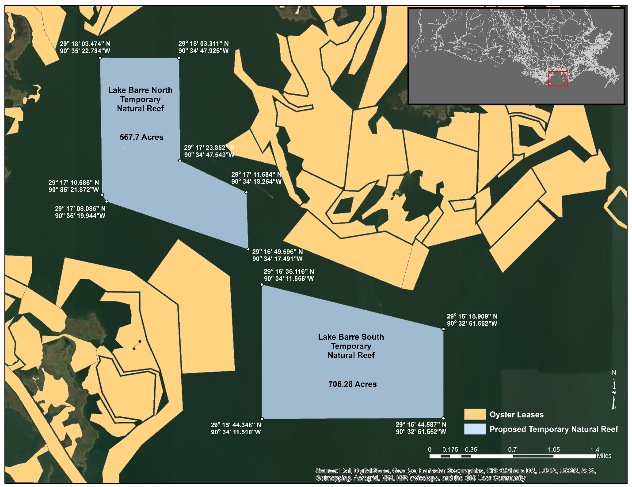
Carolina Bourque stated that in the attached map, we selected two areas to designate while attempting to include as much of the borrow site acreage as possible and leave some buffer between our boundaries and neighboring private leases. If approved, we plan to open the 1,200+ acres as a bedding-only site during the 2021/2022 oyster season well ahead of work commencement. (the 15% living material will not be applied here)
John Tesvich stated that this issue was brought up at the last meeting the task force voted to support the designation if the resource was there, requested that a biological assessment be conducted in the area
Carolina Bourque stated that the biological assessment was not performed due to a lack of funds
John Tesvich stated that he does not support changing the task forces position, suggested we do not change what was previously decided
Mitch Jurisich stated that a concern is if someone has paid for retention fee instead of the permit they would have to pay for a full priced permit and go out there only to find there is no resource, does it require having a public seed ground permit
Carolina Bourque stated that two different sources and requests from the industry stating that resource was there
Chuck Sawyer with CPRA stated that a biological assessment was performed and it was confirmed that resource was found in the area
Mitch Jurisich stated that he would like a copy of the assessment conducted by CPRA sent to the OTF, presented to the OTF before the opening of the season
C. Carolina Bourque provided a status update on the Oyster Management and Rehabilitation Strategic Plan
Strategic Plan updates and projects:
- Brood reefs East of the MS River: Petit Pass, Karako Bay, Lake Machias, Mozambique Pt- Up to ~2-acre reefs; monitoring contracted out; Construction bids open next Tuesday
- Sister Lake cultch plant- Asking for 27,000 yards, 25% allowance either way, $2,000,000+ construction budget, Bid opening – May 11th
- Drum Bay cultch plant- Planting ~100 acres in Area 2 and ~100 acres in Area 3
- Water bottom survey Morgan Harbor- Includes ~400 acres of water bottoms that lie b/n the current POSG boundary and the current shoreline. Cost ~$310,000 based on Drum Bay cost per acre of ~$38
- Hatchery Spat-on-Shell (SoS)- Producing and setting 8 million spat set on recycled oyster shells
Transport and Deployment happening today; in West Karako area
Jakov Jurisic found out yesterday there was some oyster mortality around West Karako public seed grounds, asked LDWF to try and find out the cause of the mortality, would like to know the salinities asked that Carolina Bourque email salinities from the last week and a half in areas 1,2, and 3 to the task force
Carolina Bourque stated that she can talk to the biologists and see if they have any observations that report a mortality, will be ready to collect samples and anything that happens on the seed grounds
John Tesvich motioned to take up item G. Update on Hiring Joe Piacun as OTF Legal Counsel as item C. 2nd by Jakov Jurisic. Motion carries.
C. The task force heard an update on the hiring of Joe Piacun as OTF legal counsel
Mitch Jurisich stated that at the last meeting the task force approved the immediate hiring of Joe Piacun and requested that the OTF chairman sign the contract at his earliest convenience. Signed a contract with Joe Piacun and received a letter from Secretary Montoucet stating that more specificity is needed for the scope of services that is being proposed
Duncan Kemp stated that lacking a further scope of services and lacking this LDWF cannot approve the contract, more than willing to meet with the task force. The agency has no intention of approving the contract as it is; have a fiduciary duty to monitor and approve money spent by the department and the task force and cannot approve a contract without knowing a further, more specific scope of work
Mitch Jurisich stated that he would like to amend the scope of existing engagement letter of Joseph Piacun and his law firm to represent the interests of the OTF and the Louisiana oyster industry in the following administrative pursuits:
- The proposed USACE permitting for the closure of Mardi Gras Pass
- Proposed Mid-Barataria sediment diversion
- Proposed Mid-Breton Sound sediment diversion
- To provide legal opinions on legislative issues that may affect LA’s oyster industry during the 2021 legislative session
Jakov Jurisic motioned to present the aforementioned items to the LDWF Secretary for review to further define the scope of services related to the contract with hiring Joe Piacun as OTF legal counsel, 2nd by John Tesvich. Motion carries.
Joe Piacun stated that on May 7, 2021 he received a letter from the LDWF Secretary pointing out exemptions to the proposed engagement letter that was actually approved last year by the task force and signed recently by the OTF chairman. Believed that the motion that is on the table does provide the specificity that is being asked for by LDWF, but beyond that there were two other things included in the letter- 1. That the Secretary is required to sign off on the agreement, which cites RS LA 36:802, requiring the Secretary, for agencies such as the task force, that the LDWF Secretary is required to sign off on a contracts before action is taken. Importantly what is also being suggested is that the hiring of an attorney has a dual relationship, representing both the task force and LDWF and this creates very significant conflict problems for any lawyer that has to wear two hats. The statute that the letter refers to points out that the task force as an agency in the duties, functions and responsibilities and powers that it has shall be exercised independently of the LDWF Secretary. In his opinion requiring him or any other lawyer both LDWF and the OTF is in violation of the independence required by the cited statute. Cannot accept being a lawyer for LDWF and the OTF
Duncan Kemp stated that he disagrees with Joe Piacun’s take on this, appreciate the specifics provided and will look into this and get back to the task force
D. The task force heard a legislative update on oyster related bills
Mitch Jurisich stated that they are on track to move forward with the vessel seed ground permit changes being put forward as part of the licensing increase bill, oyster harvesters license went from $100 to $15; requested that LDWF not change the harvesters license fee and leave it at $100
Peter Vujnovich motioned to request that LDWF not change the harvesters license fee, requesting to leave the fee at $100 and keep the designation of funding the same, 2nd by Jakov Jurisic. Motion carries.
Commercial fishing license went from $55 to $110
E. The task force requested that LDWF submit a comment regarding the Mid-Barataria Sediment Diversion on behalf of the oyster industry
Patrick Banks stated that he sat down with the Secretary and legal staff about submitting comment on behalf of the task forces and feel it is not appropriate, LDWF is planning to submit comment as an agency regarding the draft EIS, not on the project or permit. It is a little unclear whether the OTF is looking for comments on the EIS or on the project, or the permit.
Mitch Jurisich stated that the comment being requested on the draft EIS
The task force agrees with the findings of the EIS and therefore opposes the Mid- Barataria sediment diversion project
Patrick Banks stated that the task force has to understand the difficult position LDWF is in, under executive orders, and legal and regulatory pressure to represent the resource and the industry, but also want to be helpful and advise CPRA of what the impacts to fish and wildlife resources are from their activities, while still remaining helpful in the furtherance of coastal restoration- so it is a difficult situation. Our comment on the draft EIS will reflect the same thing. You mentioned economics and that is one of the evaluations we are taking on the EIS, looking at the economic impacts and being sure it was evaluated correctly in the EIS
John Tesvich stated that Patrick Banks mention an executive order, not sure of what exactly is in that executive order but LDWF’s function under the constitution is very clear it did not change, but things have changed a lot since CPRA was formed and maybe even a little before that when we had a little more aggressive DNR. The fact is LDWF has various duties under the constitution, LDWF is the industry’s representative at the state. Feel that CPRA is misleading people and someone should point this out within the state agencies. When it is said that it is unknown what the oyster damages are going to be that is being dishonest. They know what the damages are going to be and if they cared about it they would do a model with numbers but they told everyone to wait for the EIS and we still don’t have the numbers. LDWF has the numbers and good biologists so they can provide the data
Patrick Banks stated that LDWF is having these conversations; LDWF has shared all the data and modeling with CPRA, when CPRA has asked for advice LDWF has provided it
John Tesvich stated that it’s about misinformation, CPRA is not being honest with the information, the EIS mentions permanent loss but there are not numbers associated with it but LDWF has the numbers
George Ricks everybody just wants the truth, it would help everybody if the Wildlife and Fisheries stands up and tells the truth if it’s going to kill the dolphins, if it’s going to eliminate the shrimp, if it’s going to cause water quality problems people need to hear that
F. The task Force discussed recent resolutions passed by Plaquemines and St. Bernard Parishes in opposition to the Mid-Barataria sediment diversion draft EIS
Mitch Jurisich stated that Plaquemines, St. Bernard, and St. Tammany parishes did pass resolutions opposing the draft EIS. It’s a statement when the parish that the diversion is going to go into stands up with unanimous votes. Hoping Jefferson Parish will pass something as well
Grand Isle will take up this issue tomorrow night at 6:00pm at the Grand Isle Complex
G. Thomas Hymel stated that Sea Grant is raising funds to have meals at the 2022 LA Fisheries Forward Summit
Peter Vujnovich motioned to dedicate $5,000 in funding towards the 2022 LA Fisheries Forward Summit, 2nd by Shane Bagala. Motion carries.
VII. Public Comment:
Jack Isaacs stated that the legislature, the House is considering a resolution asking LDWF to figure out what happens to the oyster shells that are produced from Louisiana oysters. Will need to come visit and speak to processors and dealers to ask some questions and gather some information on this
Harry Vorhoff stated that a point of clarification from the earlier conversation regarding the mitigation funding, the funding would come from NERDA from the Deep Water Horizon Spill
Duncan Kemp requested that LDWF be sent a copy of the new proposed contract with Joe Piacun
George Ricks suggested that everyone submit comment regarding the Mid-Barataria draft EIS to Corps and LA TIG by June 3rd
VIII. The task force did not set their next meeting at this time, next meeting date TBD
IX. Peter Vujnovich motioned to adjourn the meeting, 2nd by Willie Daisy. Motion carries.

